Темы по английскому языку для 2 курса по разделу
«Образование»

Тематическое содержание

Тема 1. The System of Education in Russia/ Система образования в России
Тема 2. The System of Education in Great Britain/ Система образования в Великобритании
Тема 3. The oldest universities in England/ Старейшие университеты Англии
Тема 4. Education in the USA / Образование в США
Тема 5. I am a college student / Я- студент колледжа

Контроль знаний. Тест в режиме онлайн.

Good day my students! Today is the 21st of October 2020
We begin to work on the Unit Education.
Тема 1. The System of Education in Russia

Цель урока:
- ознакомление с системой образования в школах Российской Федерации;
- развитие навыков обучающихся в чтении с извлечением детальной информации;
- развитие навыков монологической речи с употреблением лексики по теме «The System of Education in Russia».

Деятельность студентов на уроке

- Прочитайте и переведите текст " The System of Education in Russia".

Education plays a very important role in our life. All Russian children have the right to education, but it is not only a right, it is a duty, too. The citizens of Russia have a right to receive the education which is guaranteed in the Constitution of the Russian Federation.
Education is a key to a good future. And schools are the first step on the education-way. Schools help young people to choose their career, to prepare for their future life; they make pupils clever and well-educated. They give pupils the opportunity to fulfill their talent.
The system of education in Russia is very much the same as in other highly developed countries. Education in our country is compulsory and now lasts eleven years. School term has 3 stages: elementary (grades 1-4), middle (grades 5-9) and senior (grades 10-11) classes.
There are nurseries and kindergartens for little children aged from 2 to 6. Children play games, go for walks, and have regular meals there. But the lessons of reading, arithmetic, drawing and other subjects have become more complicated than they were in the kindergartens ten years ago. There are the kindergartens where children learn foreign languages.
At the age of 6 or 7 Russian children go to secondary schools. The level of education in Russian secondary schools is rather high. Children receive primary education during the first four years.
Then they enter the middle school. In the middle school pupils study: Russian and foreign languages, Russian literature, algebra, geometry, physics, chemistry and biology. They have their final examinations in the ninth form.
Then the pupils may leave school and enter some professional college or receive full-time secondary education in the tenth and eleventh forms. The program of the last two years is the most complicated one. Besides the subjects mentioned above it often includes trigonometry, organic chemistry and astronomy. Pupils get the necessary knowledge for entering the universities and institutes. There are some special schools where pupils have advanced programs in physics, mathematics or foreign languages.
Every city in Russia has at least one university and several institutes. The oldest Russian universities are the Moscow State University, the University of St. Petersburg and some others.
2. Запишите в конспект и запомните слова и выражения по теме "The System of Education in Russia":
gradually - постепенно
creation - создание
nursery - ясли
considerably - значительно
full-time secondary education - полное среднее образование
trigonometry - тригонометрия
organic chemistry - органическая химия
entry - поступление
advanced - продвинутый, углубленный
at least - no меньшей мере

3. Ответьте на вопросы по содержанию текста:
1.What establishments are organized for children from 2 to 6?
2. What do children do in the kindergartens?
3. What age is the compulsory school age in Russia?
4. How many years does the primary school include?
5. What subjects do pupils of the middle school study?
6. Can pupils leave school after the ninth form?
7. How many years do they attend school to receive full-time secondary education?
8. What subjects do they study during the final two years?
Конспекты с выполненными работами во время урока я проверю после окончания изучения раздела Образование.
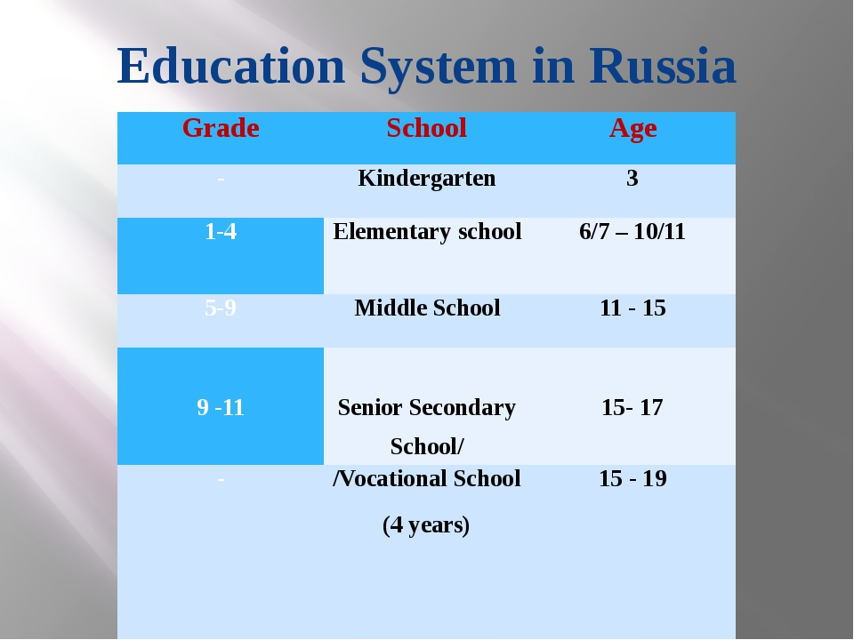

Деятельность студентов при выполнении домашнего задания
Оформляем файл как в инструкции студентам:
Например, Малов М_А-21_Английский язык_20.10и это пишем в теме письма когда отправляете письмо на адрес dzntmsh@mail.ru
1.Найти и выписать из текста предложения, содержащие слова
key to a good future
enter some professional college
it is not only a right, it is a duty
foreign languages
get the necessary knowledge
advanced programs
highly developed countries.
- Составить из слов логически завершенные предложения(3)записать с переводом:
- middle school, enter,after, universities and institutes,leaving,students, can, the.
- Learn, subjects, at, different, the primary school,they, a lot of.
- the compulsory, go to, school, age, Russia, children, secondary schools, at.

